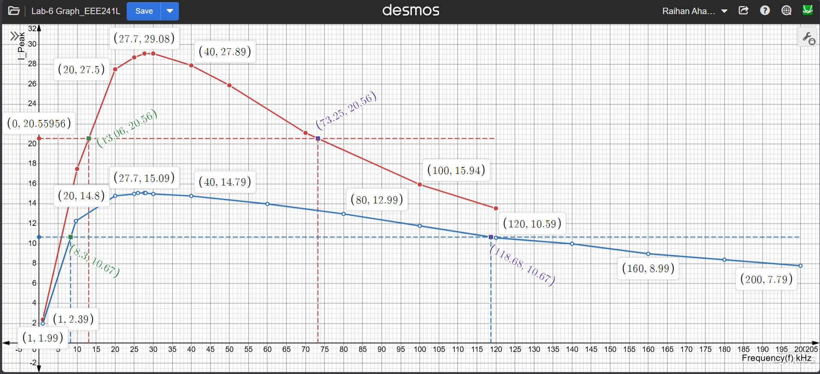
Figure. G1 : I_Peak VS Frequency(kHz) Graph of Series RLC Circuit

